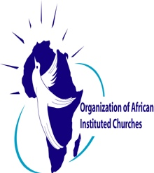

admin@oaic.org

11th April 2020

Dear OAIC Member Churches,

In a few hours many of us will tell the story of the resurrected Lord and Saviour Jesus Christ. As we read/tell the story of the empty tomb we do this as the world and specifically our nations and local communities are grappling with the reality of COVID-19.

This Easter will go down in the annals of history as one where the curtains we erect and call them boards have been infiltrated by a common enemy. We have been reshaped into a new humanity as the world we knew has changed. Some of the new ways we live our life is in quarantine, watching businesses coming to a standstill, the lockdown that has led to the closing of churches, schools and impacting other forms of community life, fellowship with family and friends has been put on hold, many have lost their source of livelihood.

The certainty that we hold on comes from our faith in the risen Christ who defeated death and rose from the dead. With this we can find the courage to proclaim that Christ is risen at every opportunity. This can be by supporting people in distress due to the multiple losses they are experiencing, sending out messages on radio, using SMs, using the internet and singing in our homes the songs of Christ’s Resurrection.

Our actions in prayer, community education, charity, supporting families in distress, and engaging public institutions in relation to the people who are being socially and economically distanced by the reality of covid 19 is anchored in our faith and hope in the risen Christ. It is the reason we have always continued to serve and bring hope in difficult circumstances for abundance of life.

Brothers and Sister no matter what is going on in the world, we know that God has the whole world in His hands and for this we take comfort. As we read/tell the Easter story, the greatest message we can convey to others this Easter is that we have been given the opportunity not to tell the story but to live the story of our Lord and Saviour.
"Praise be to the God and Father of our Lord Jesus Christ! In his great mercy he has given us new birth into a living hope through the resurrection of Jesus Christ from the dead." 1 Peter 1:3

He Is Risen Indeed
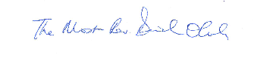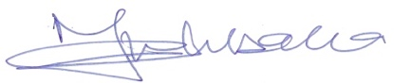
Most Reverend Dr. Daniel Okoh Rev. Nicta Lubaale
International Chairman General Secretary

